Bryan Cabrera

3/29/2024

Module 2.3 Assignment

ERD:

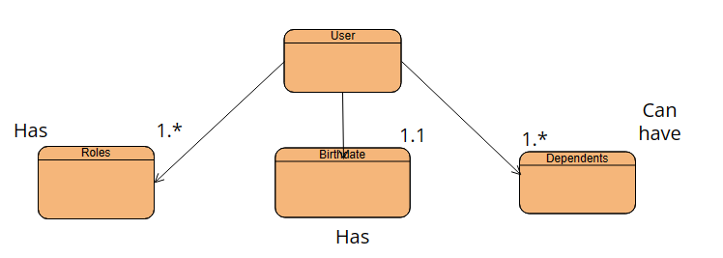

NoSQL Data Structure:

{

"user_id": "123",

"roles": ["admin", "editor"],

"birthdate": "1990-01-01",

"dependents": [

{

"name": "Dependent1",

"relationship": "child",

"birthdate": "2010-05-15"

},

{

"name": "Dependent2",

"relationship": "spouse",

"birthdate": "1990-08-20"

}